2012
“Year of Peoples Right Over Land and Livelihood Resources”

Through
“Peoples Commission on Land and Livelihood Resources”

Which results in
“A comprehensive land reforms Policy/Legislation”

Come and Join
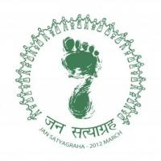
Jan Satyagraha 2012
One Lakh people marching on foot from Gwalior to Delhi on 2nd October 2012
www.jansatyagraha.org
delhi@ektaparishad.com

